Nalongsone Danddank Student ID : 14958950 StarID: jf3893pd

Email: [nalongsone.danddank@my.metrostate.edu](mailto:nalongsone.danddank@my.metrostate.edu)

Homework 8 *(16/15* pts)[1]

You come to Metro State to take a second bachelor’s degree in Computer Science. Your first degree is in some subject that requires only College Algebra.[2] To do a CS major, you would need to take the following courses:

Math 120, 210, 215; ICS 140, 141, 232, 240, 311, 340, 365, 372, 440, 460, 462, 499

You want to finish in 6 semesters (numbered 1-6). The diagram below indicates which courses are prerequisites for which other courses (so, ICS 141 < ICS 240 means that ICS 141 is a prerequisite for ICS 240), or which must be taken before-or-with another course (so Math 215 <= ICS141 means you can take Math 215 first, or in the same semester as ICS 141).

Assume that every course is offered every semester, and that there are no day/time conflicts (so that whatever set of 2 or 3 courses you take in a given semester, you can find times to take them concurrently)

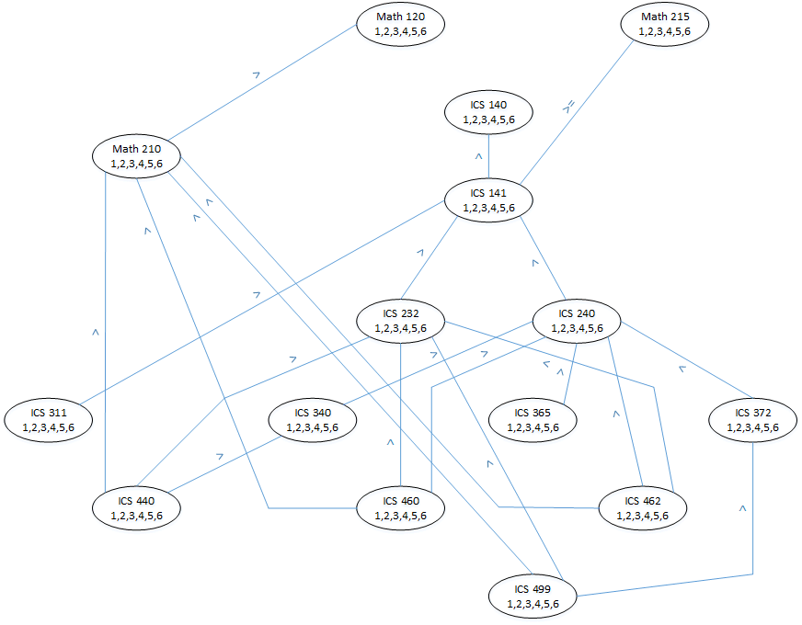

For those of you who prefer to see the constraints in text form, here they are:

1. Math 120 < Math 210
2. Math 215 <= ICS 141
3. ICS 140 < ICS 141
4. Math 210 < ICS 440
5. Math 210 < ICS 460
6. Math 210 < ICS 462
7. Math 210 < ICS 499
8. ICS 141 < ICS 232
9. ICS 141 < ICS 240
10. ICS 141 < ICS 311
11. ICS 232 < ICS 440
12. ICS 232 < ICS 460
13. ICS 232 < ICS 462
14. ICS 232 < ICS 499
15. ICS 240 < ICS 340
16. ICS 240 < ICS 365
17. ICS 240 < ICS 372
18. ICS 240 < ICS 460
19. ICS 240 < ICS 462
20. ICS 340 < ICS 440
21. ICS 372 < ICS 499
22. [5/5 pts] Prune the domains of the courses so that the diagram is arc-consistent. In the lines below, list the semesters in the pruned domain of each course.

***Solution:*** Pruned domains:

|  |  |
| --- | --- |
| Course | Pruned domain |
| Math 120 | 1, 2, 3, 4 |
| Math 210 | 2, 3, 4, 5 |
| Math 215 | 1, 2, 3 |
| ICS 140 | 1, 2 |
| ICS 141 | 2, 3 |
| ICS 232 | 3, 4, 5 |
| ICS 240 | 3, 4 |
| ICS 311 | 3, 4, 5, 6 |
| ICS 340 | 4, 5 |
| ICS 365 | 4, 5, 6 |
| ICS 372 | 4, 5 |
| ICS 440 | 5, 6 |
| ICS 460 | 4, 5, 6 |
| ICS 462 | 4, 5, 6 |
| ICS 499 | 5, 6 |

1. [3/3 pts] Suppose you limit yourself to at most three courses in a semester. Propose a schedule that allows you to graduate in six semesters while meeting all the prerequisite requirements. In each of the boxes below, list the courses that you would take in that semester. There are many correct answers

***Solution:*** Semester schedules

|  |  |  |  |
| --- | --- | --- | --- |
| Semester | Course 1 | Course 2 | Course 2 |
| Semester 1 | Math 120 | Math 215 | ICS 140 |
| Semester 2 | Math 210 | ICS 141 |  |
| Semester 3 | ICS 240 | ICS 311 | ICS 232 |
| Semester 4 | ICS 372 | ICS 340 | ICS 365 |
| Semester 5 | ICS 440 | ICS 462 | ICS 460 |
| Semester 6 | ICS 499 |  |  |

1. [8/8 pt] Here is a diagram and table of the set of legal domains for courses from the Quiz of March 15. Using these legal domains, eliminate variable ICS 372. Do this by filling out the following four tables. In each case, you may or may not need all the columns.

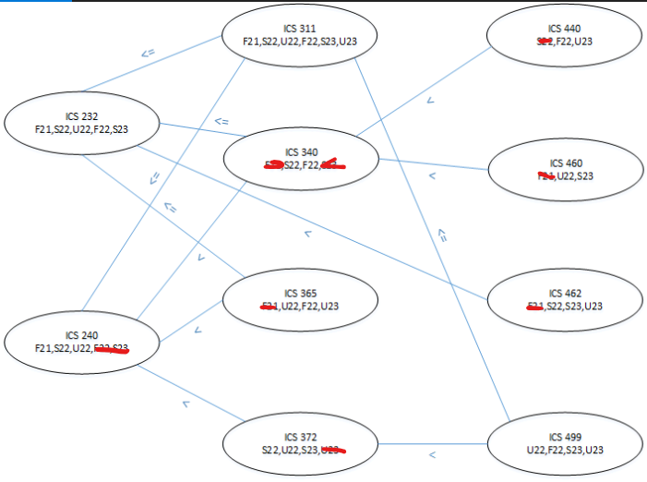

|  |  |
| --- | --- |
| Course | Pruned domain |
| ICS 240 | F21, S22, U22 |
| ICS 372 | S22, U22, S23 |
| ICS 499 | U22, F22, S23, U23 |

Part A [2 pt]: Show the legal combinations of ICS 240 – ICS 372 semesters.

|  |  |  |  |  |  |  |  |  |
| --- | --- | --- | --- | --- | --- | --- | --- | --- |
| ICS 240 | F21 | F21 | F21 | S22 | S22 | U22 |  |  |
| ICS 372 | S22 | U22 | S23 | U22 | S23 | S23 |  |  |

Part B [2 pt]: Show the legal combinations of ICS 372 – ICS 499 semesters.

|  |  |  |  |  |  |  |  |  |
| --- | --- | --- | --- | --- | --- | --- | --- | --- |
| ICS 372 | S22 | S22 | S22 | S22 | U22 | U22 | U22 | S23 |
| ICS 499 | U22 | F22 | S23 | U23 | F22 | S23 | U23 | U23 |

Part C [2 pt]: Show the legal triples of ICS 240 – ICS 372 – ICS 499 semesters. (a.k.a., do a join)

|  |  |  |  |  |  |  |  |  |  |  |  |  |  |
| --- | --- | --- | --- | --- | --- | --- | --- | --- | --- | --- | --- | --- | --- |
| ICS 240 | F21 | F21 | F21 | F21 | F21 | F21 | F21 | F21 | S22 | S22 | S22 | S22 | U22 |
| ICS 372 | S22 | S22 | S22 | S22 | U22 | U22 | U22 | S23 | U22 | U22 | U22 | S23 | S23 |
| ICS 499 | U22 | F22 | S23 | U23 | F22 | S23 | U23 | U23 | F22 | S23 | U23 | U23 | U23 |

Part D [2 pt]: Show the legal combinations of ICS 240 – ICS 499 (a.k.a., do a projection)

|  |  |  |  |  |  |  |  |  |
| --- | --- | --- | --- | --- | --- | --- | --- | --- |
| ICS 240 | F21 | F21 | F21 | F21 | S22 | S22 | S22 | U22 |
| ICS 372 | U22 | F22 | S23 | U23 | F22 | S23 | U23 | U23 |

1. Note that > 15 points are possible, so basically this homework includes a little extra credit.
2. We usually take science and engineering degrees in lieu of electives or a minor. However, given the wide applicability of computing, we also occasionally take degrees in Art, Music, or Political Science, for instance.